LAB ACTIVITY (Exp-08)

Q1) Represent tree data structure with array
#include <stdio.h>
#define MAX 50

int tree[MAX];
int n;

void inputTree() {
printf("Enter number of nodes in the binary tree: ");
scanf("%d", &n);

printf("Enter %d node values (level-wise):\n", n);
for (int i = 0; i < n; i++) {
printf("Node %d: ", i);
scanf("%d", &tree[i]);
}
}

void displayTree() {
printf("\nBinary Tree (Array Representation):\n");
for (int i = 0; i < n; i++) {
printf("Index %d-->Data:- %d\n", i, tree[i]);
}
}

void showRelations() {
printf("\nParent–Child Relationships:\n");
for (int i = 0; i < n; i++) {
int left = 2 * i + 1;
int right = 2 * i + 2;

printf("Parent: %d ", tree[i]);
if (left < n)
printf("| Left Child: %d", tree[left]);
else
printf("| Left Child: None");

if (right < n)
printf(" | Right Child: %d", tree[right]);
else
printf(" | Right Child: None");

printf("\n");
}
}

int main() {
inputTree();
displayTree();
showRelations();
return 0;
}

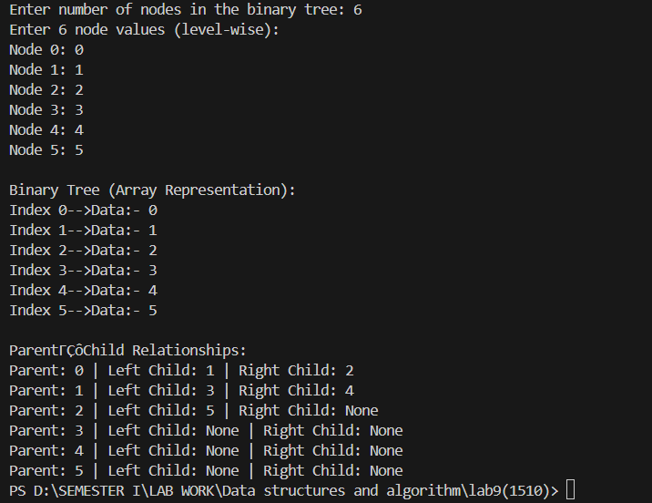

Q2) Represent Tree data structure with linked list

Q3) apply pre, in, post,level order traversal to display

Q4) search an element from a binary tree

#include <stdio.h>
#include <stdlib.h>

struct Node {
int data;
struct Node *left, *right;
};

struct Node* createNode(int value) {
struct Node* newNode = (struct Node*)malloc(sizeof(struct Node));
newNode->data = value;
newNode->left = newNode->right = NULL;
return newNode;
}

struct Node* createTree() {
int data;
printf("Enter root node data (-1 for no tree): ");
scanf("%d", &data);

if (data == -1)
return NULL;

struct Node* root = createNode(data);

struct Node* queue[50];
int front = 0, rear = 0;
queue[rear++] = root;

while (front < rear) {
struct Node* current = queue[front++];

printf("Enter left child of %d (-1 for no left child): ", current->data);
scanf("%d", &data);
if (data != -1) {
current->left = createNode(data);
queue[rear++] = current->left;
}

printf("Enter right child of %d (-1 for no right child): ", current->data);
scanf("%d", &data);
if (data != -1) {
current->right = createNode(data);
queue[rear++] = current->right;
}
}

return root;
}

void levelOrder(struct Node* root) {
if (root == NULL) {
printf("Tree is empty.\n");
return;
}

struct Node* queue[50];
int front = 0, rear = 0;

queue[rear++] = root;

printf("Level Order Traversal: ");
while (front < rear) {
struct Node* current = queue[front++];
printf("%d ", current->data);

if (current->left)
queue[rear++] = current->left;
if (current->right)
queue[rear++] = current->right;
}
}

void preorder(struct Node* root) {
if (root == NULL) return;
printf("%d ", root->data);
preorder(root->left);
preorder(root->right);
}

void inorder(struct Node* root) {
if (root == NULL) return;
inorder(root->left);
printf("%d ", root->data);
inorder(root->right);
}

void postorder(struct Node* root) {
if (root == NULL) return;
postorder(root->left);
postorder(root->right);
printf("%d ", root->data);
}

int search(struct Node* root, int key) {
if (root == NULL)
return 0;

if (root->data == key)
return 1;

return search(root->left, key) || search(root->right, key);
}

int main() {
struct Node* root = createTree();
printf("\n");
levelOrder(root);

printf("\nPreorder Traversal: ");
preorder(root);

printf("\nInorder Traversal: ");
inorder(root);

printf("\nPostorder Traversal: ");
postorder(root);

int key;
printf("\n\nEnter element to search: ");
scanf("%d", &key);

if (search(root, key))
printf("Element %d found in the tree.\n", key);
else
printf("Element %d not found in the tree.\n", key);

return 0;
}

